Note¹: All labs are mandatory and you will be marked on 4, randomly chosen out of 12 labs. These will account for 20% of your overall mark (5% each).
Note^{2:}: If a marker requests for a specific lab (e.g. Lab 3) and you do not have Lab 3 available, you can ask for another lab to be marked (e.g. Lab 2) but the total marks for Lab 2 will be reduced by 50%.
Note³: All the labs should be created on one single document following the provided template, saved in your drive (or computer) and accessible anytime. Labs are individual works and they will be submitted into Moodle Dropbox at the end of the TB1.
Note⁴: If a LAB is not finished in the scheduled session you should complete it at your most convenient time by the beginning of the next session.
Note⁵: Use a code editor and do not type into VM directly
Online syntax and technical documentations: https://devdocs.io/

LAB 7

NOTE: Using movie_rental database (LAB 5), you will need to change between superuser role and the new created roles. You can use two terminals. Look for specific syntaxes for login with other roles and the roles permissions in the lecture slides or documentation.

- Create read-only access to the "staff" table to a new role called "junior_analyst". In order to achieve this you will need to follow a couple of steps. The steps order is given but you will need to write the code (syntaxes). Use 2 terminals - one for super admin (your UP number, connected to the movie_rental database) and one for the created role.
  - -- Create the Role junior_analyst with a Password and login rights
    - CODE:
  - – Login with junior_analyst role (using 2nd terminal)
    - psql -h localhost -p 5432 -U junior_analyst -d movie_rental
  - – Try to select the staff table
    - SELECT * FROM staff;
    - You should have the following error: “permission denied for table staff”
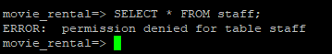
  - -- Grant SELECT on the table STAFF to the role junior_analyst:
    - CODE:

  - – Select staff table again. You should be able to see staff table data.

- Following a similar process as above, how would you grant INSERT access to the "payment_p2022_01" table to a new role called "cashier"?

Use 2 terminals again
  - Create the role with correct logins and access level
    - CODE:
  - Grant the insert access for cashier role for the table payment_p2022_01.
    - CODE:
  - Login with cashier role (using 2nd terminal)
    - psql -h localhost -p 5432 -U cashier -d movie_rental
  - Try to make the following INSERT. Depending on how you granted the permissions, you might have an error. Fix the error on grant. Read the error message carefully and look up how to fix it. If no error is generated and the INSERT was made, move to question 3.
INSERT INTO payment_p2022_01(customer_id, staff_id, rental_id, amount, payment_date) VALUES (1, 1, 1, 5.99, CURRENT_TIMESTAMP);
--this bloody thing
GRANT USAGE, UPDATE ON SEQUENCE payment_p2022_01_payment_id_seq TO cashier;

- Using the cashier role, try to SELECT * FROM rental;. You should not be able to do so.
  - Switch to your superuser role and allow the role cashier to make SELECT and INSERT from rental table.
    - CODE:
  - Using the 2nd terminal (with cashier role) make the following INSERT:
INSERT INTO rental (rental_id, rental_date, inventory_id, customer_id, return_date, staff_id, last_update)
VALUES (17000, CURRENT_DATE, 1, 1, NULL, 1, CURRENT_TIMESTAMP);
- see if the insert was made (you should have the today date)
SELECT * FROM rental WHERE rental_id = 17000;
  - Using the role of cashier, DELETE the record with ID 17000
DELETE FROM rental WHERE rental_id = 17000;
  - It should fail. How can you fix this and delete the record using the cashier role?
GRANT DELETE ON rental TO cashier;

- How would you give a role named "manager" the ability to update the "country" table and also give them permission to grant this privilege to another role called “sales”?
  - Create the role manager with all necessary permissions (login, update and to grant permissions to others)
psql -U up2271401 -d movie_rental -c "CREATE ROLE manager LOGIN PASSWORD '5432';" --create manager and sales
CODE: GRANT SELECT, INSERT, UPDATE, DELETE ON TABLE country TO manager WITH GRANT OPTION;

  - Create a role sales but only login permissions
psql -U up2271401 -d movie_rental -c "CREATE ROLE sales LOGIN PASSWORD '5432';"

  - Login as manager and grant the UPDATE on COUNTRY permission for sales role
psql -h localhost -p 5432 -U manager -d movie_rental
    - CODE:
GRANT UPDATE ON country TO sales;
  - Login as sales make the following update
psql -h localhost -p 5432 -U sales -d movie_rental
UPDATE country SET last_update = NOW() WHERE country_id = 102;
Most likely you will have an error - Why? Think to the Transaction Analysis. Adjust the privileges for ‘manager’ and ‘sales’ and perform the UPDATE from ‘sales’ account.
  - Check if the update was successful as sales - for last_update you should have the current data and time.
SELECT * FROM country WHERE country_id=102;
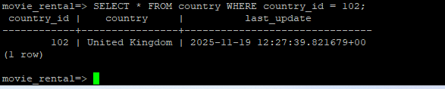

- Using the superuser role, create the following VIEW:
CREATE VIEW customer_view AS SELECT * FROM customer;

  - How you will allow the "sales" role the ability to access the view without granting them direct access to the table?
    - CODE:
GRANT SELECT ON customer_view TO sales;

  - SELECT * FROM customer; should fail with “ERROR: permission denied for table customer”
SELECT * FROM customer_view; Should work without any issue

- As superuser add a new staff member
INSERT INTO staff (staff_id, first_name, last_name, address_id, email, store_id, active, username, password, last_update, picture)
VALUES (3, 'Val','Adam', 5,'val.adam@sakilastaff.com', 1,'t', 'valadam', '8cb2237d0679ca88db6464eac60da96345513964', CURRENT_TIMESTAMP, NULL);
  - Create a new role as “admin” that will have the capability to create new roles.
  - Assign the staff named “Val” to admin group.
  - If everything was executed correctly, running the \du command you should have the following entry
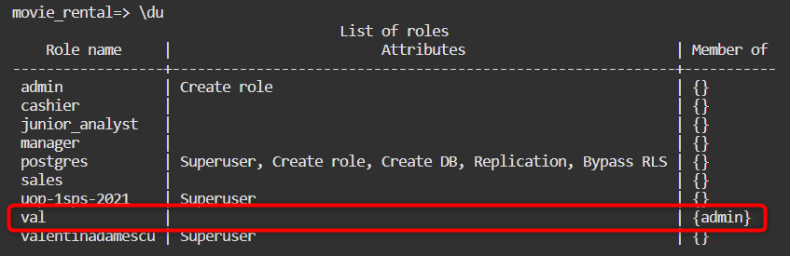
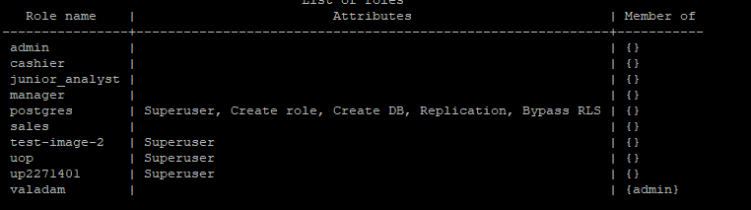
NOTE: In PostgreSQL the users and the groups have both name as ROLE - I know it doesn’t make sense, but this is the official description “PostgreSQL manages database access permissions using the concept of roles. A role can be thought of as either a database user, or a group of database users, depending on how the role is set up Source: PostgreSQL”

- How would you create a role "senior_analyst" that is able to create new tables, drop the created tables, view data in those tables but without the ability to read or modify the data from existing tables?
  - After role creation try to CREATE TABLE new_table (); It should work
  - SELECT * FROM customer; it should fail

